**Experiment No. 1.3**

**Student Name: Rishav Kumar UID: 22MCC20039**

**Branch: MCA - CCD Section/Group: MCD-1/ Grp A**

**Semester: III Date of Performance: 7th Sep 23**

**Subject Name: Business Analytics Subject Code: 22CAH-703**

1. **Aim/Overview of the practical:**

a) Assign a name to a range of cells to make it easier to reference those ranges in calculations, create a drop-down menu to make data entry quicker and more efficient.

b) Use sort and filter to find and organize data in large databases, custom filters.

1. **Code for practical:**

**A.)**

* Open a worksheet with any data.
* Select any range of cells.

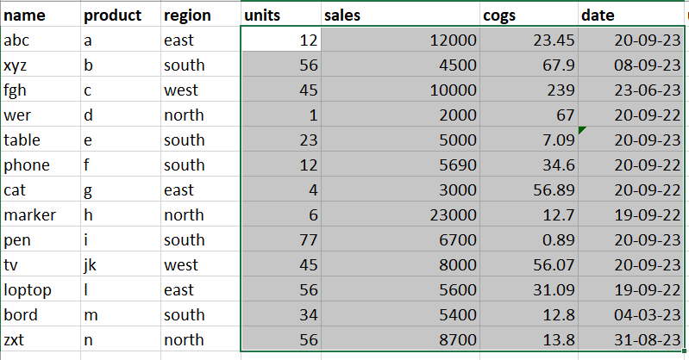

* Go to ***Formulas > Define Name***
* Enter name you want to use for that range.
* Select the scope of the name and confirm range for that name.

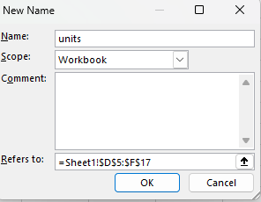

* To create a drop-down menu, click on any cell.
* Go to ***Data > Data Validation***.
* Click on list and enter the list items for drop down menu.

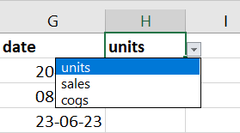

**B.)**

* To sort data in ascending or descending order, click on sort and filter in Home tab click on the order you want to use.

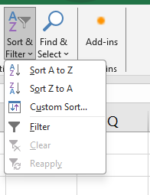

* To view any selected data, we can use filter.
* Click on filter, drop down menu will be shown on all cells in first row.

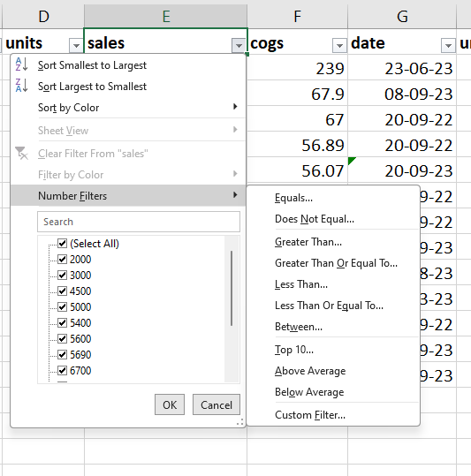

* User can enter condition to view data greater than or less than to any specific value.

**************************************** **THE END** ***********************************************